**Appendix 3 Activity and sequence diagrams**

**1 Activity Diagram**

* 1. **Add an appointment**

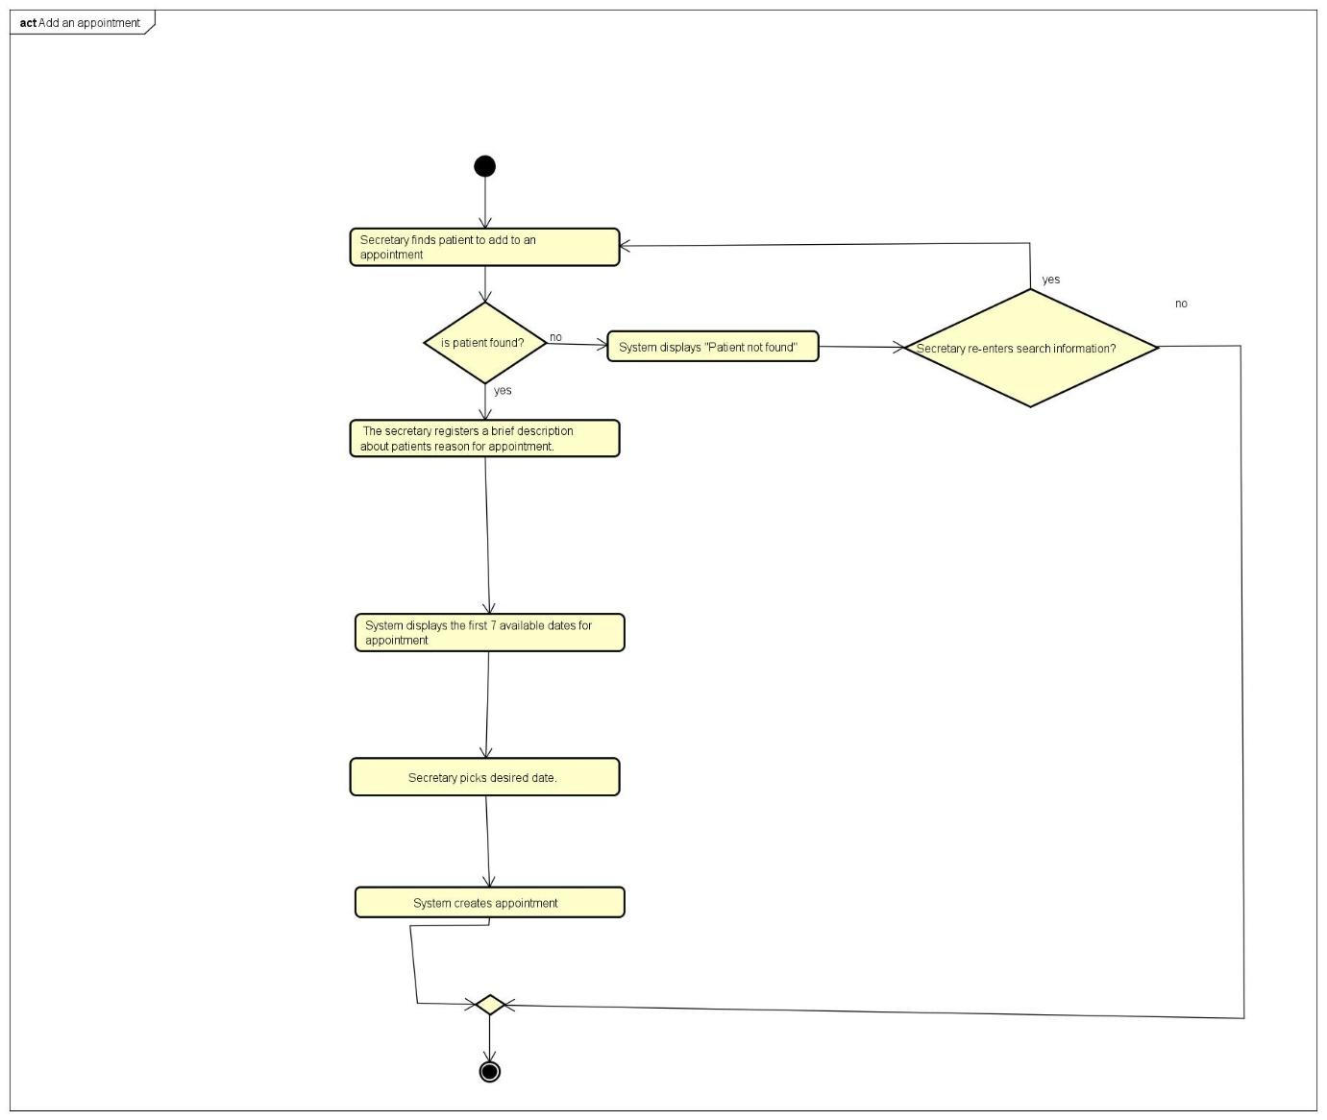

* 1. **Add an employee**

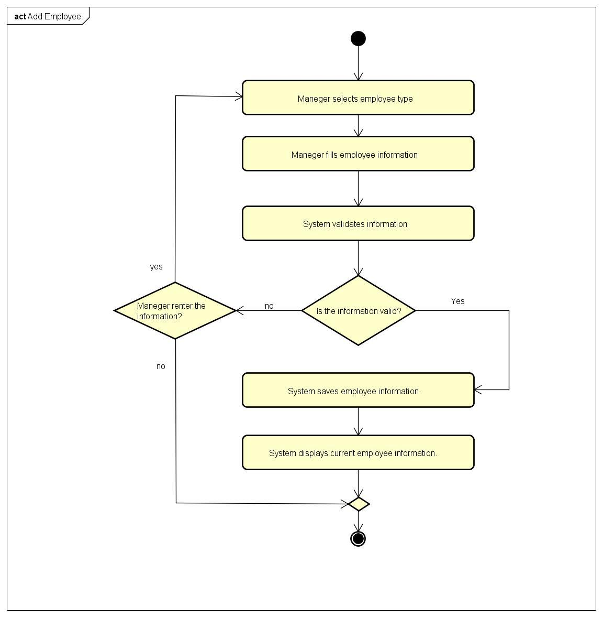

* 1. **Add medical case**

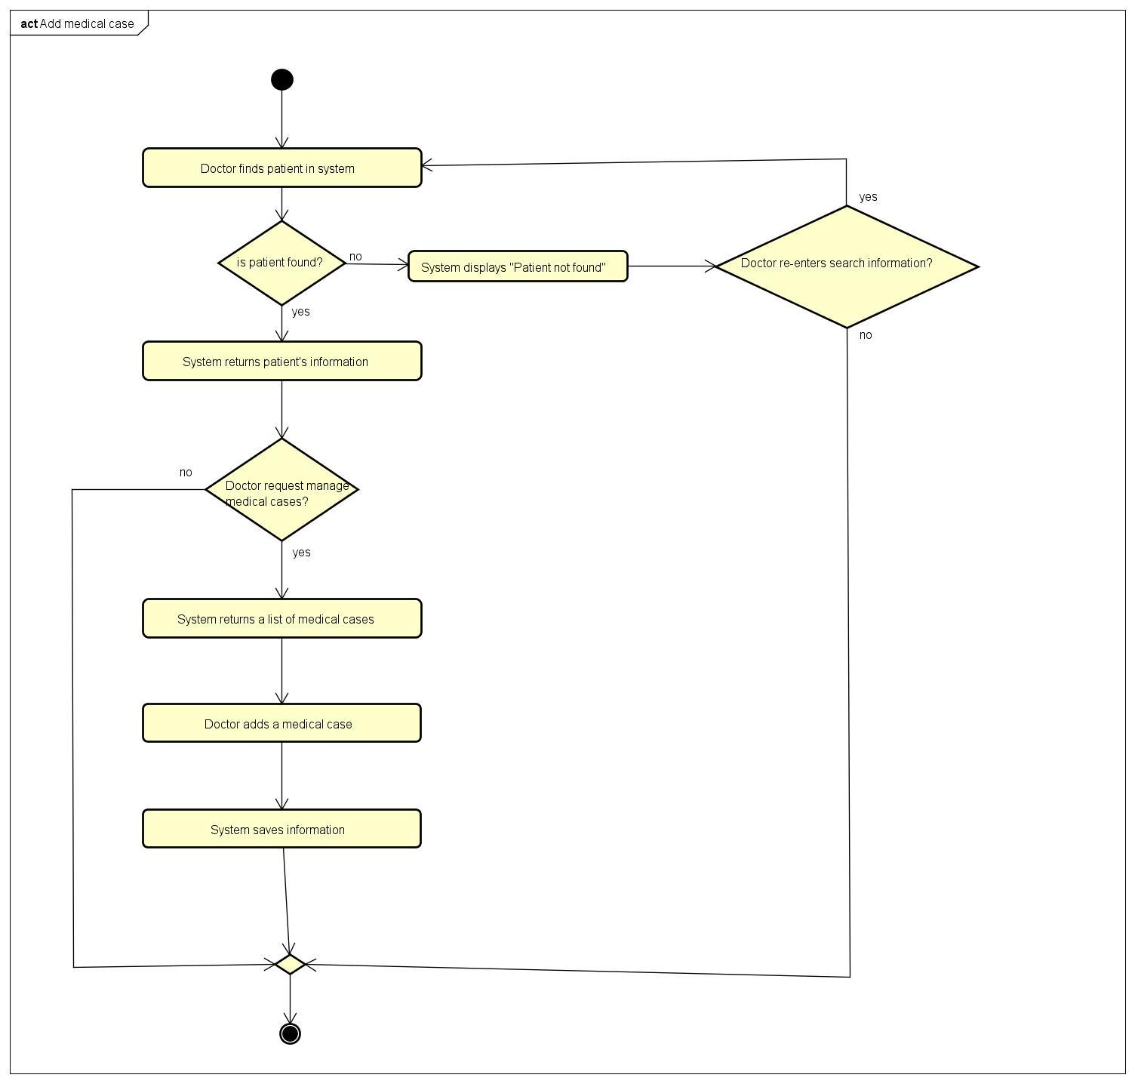

* 1. **Add medical prescription**

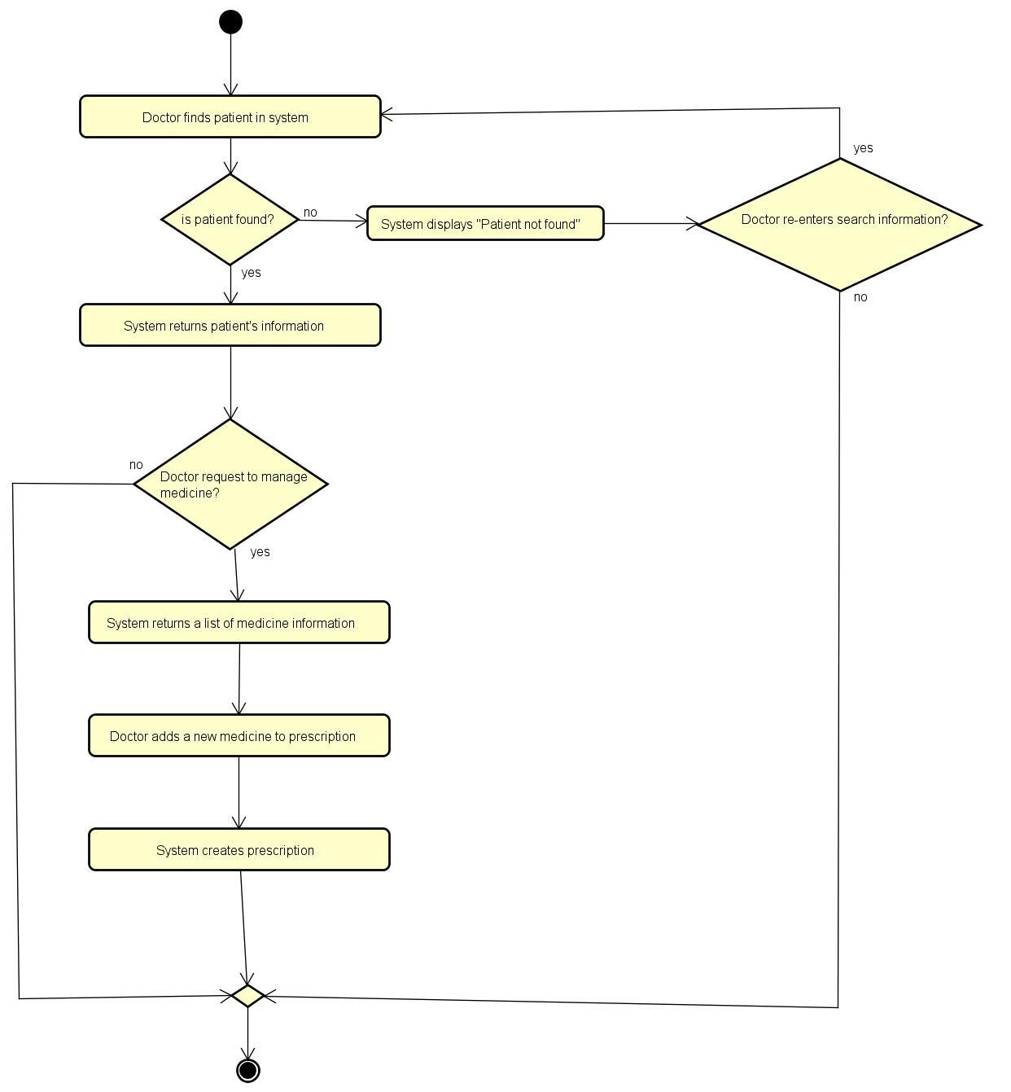

* 1. **Add a patient**

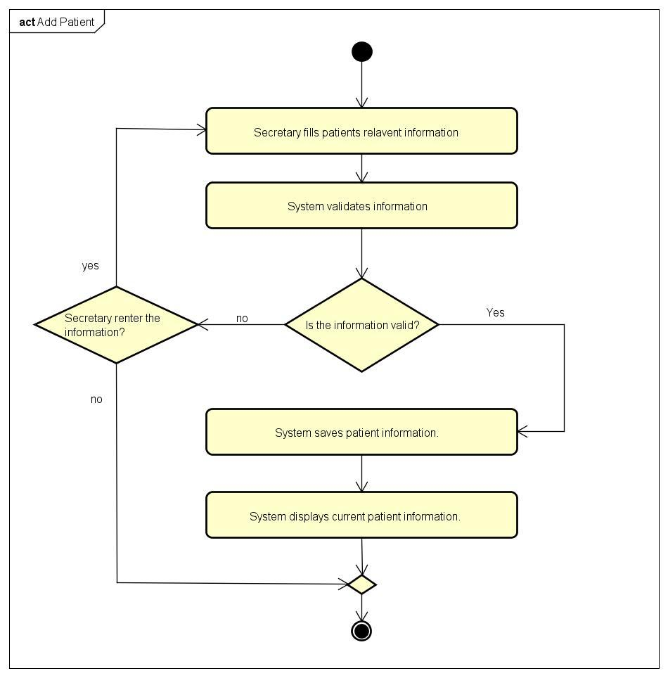

**1.6 Add medicine**

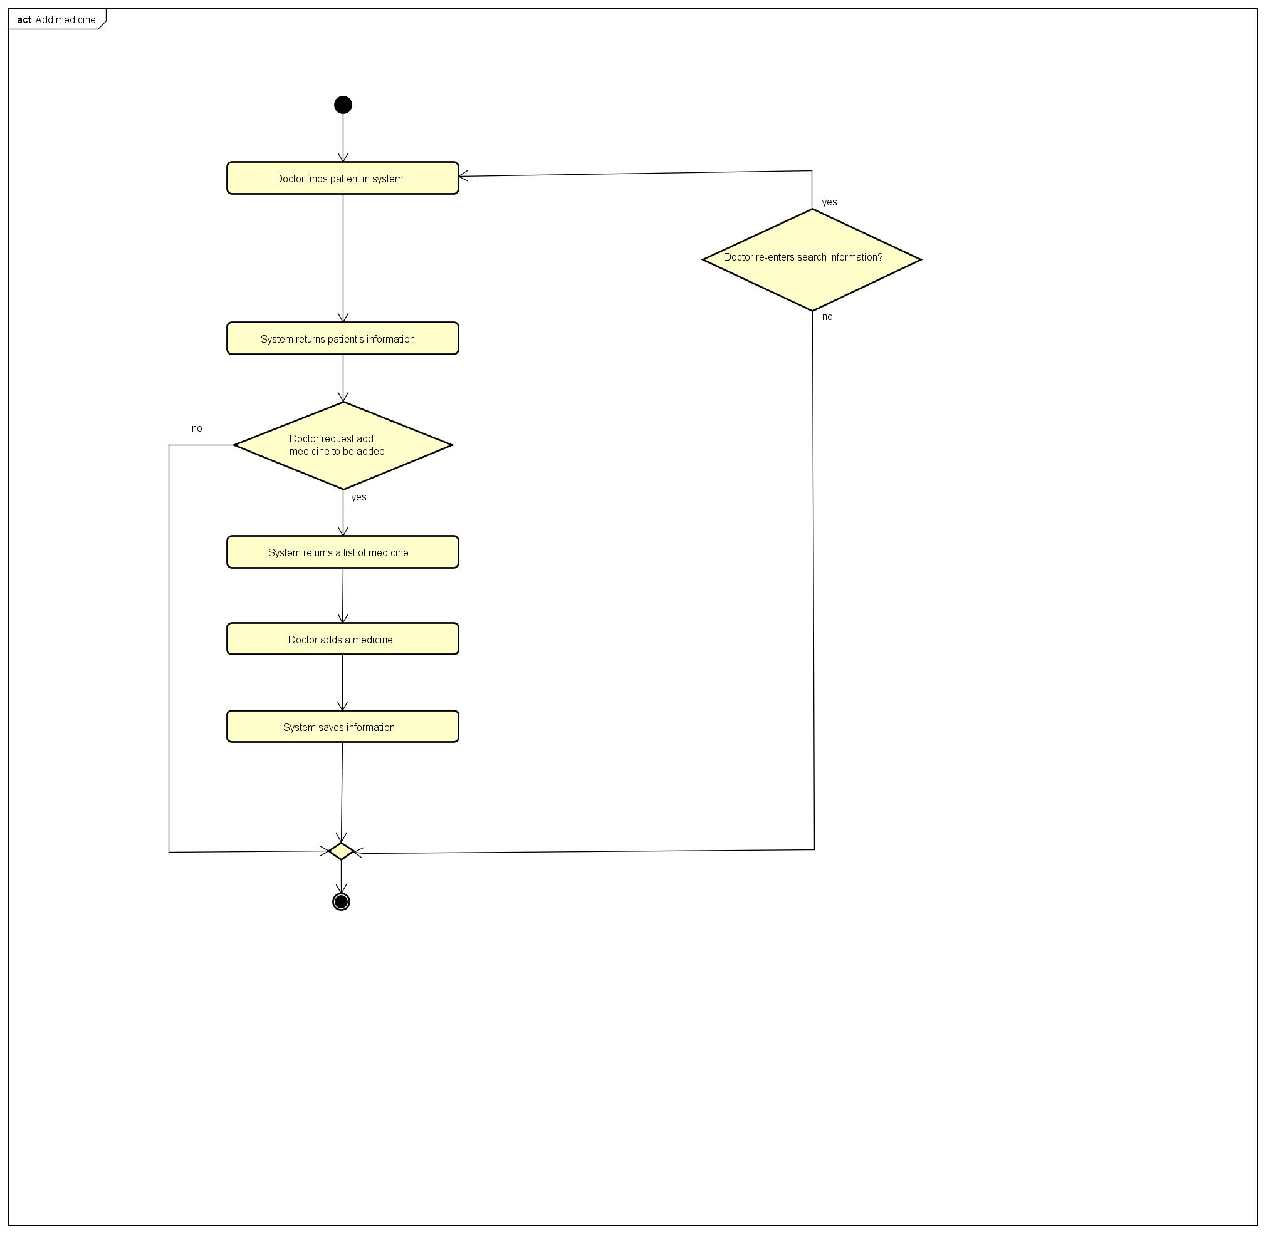

**1.7 Approve medical request**

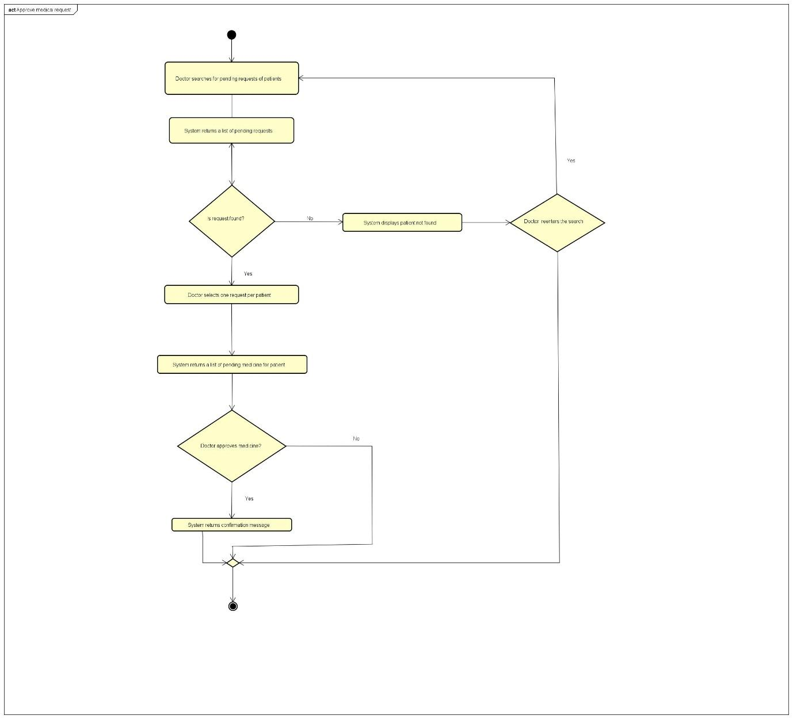

**1.8 Edit an appointment**

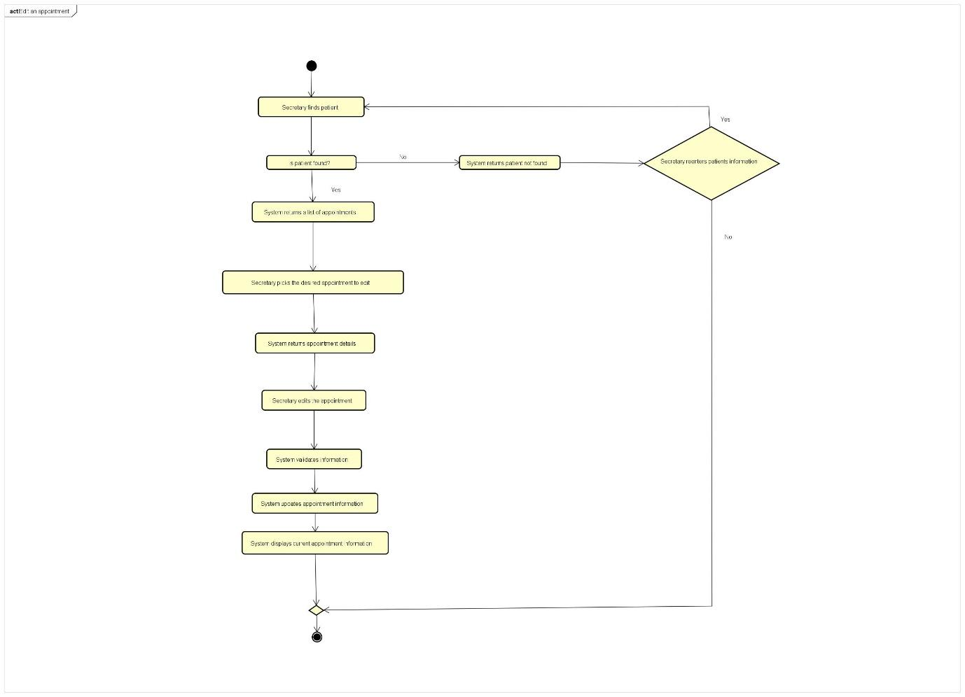

**1.9 Edit an employee**

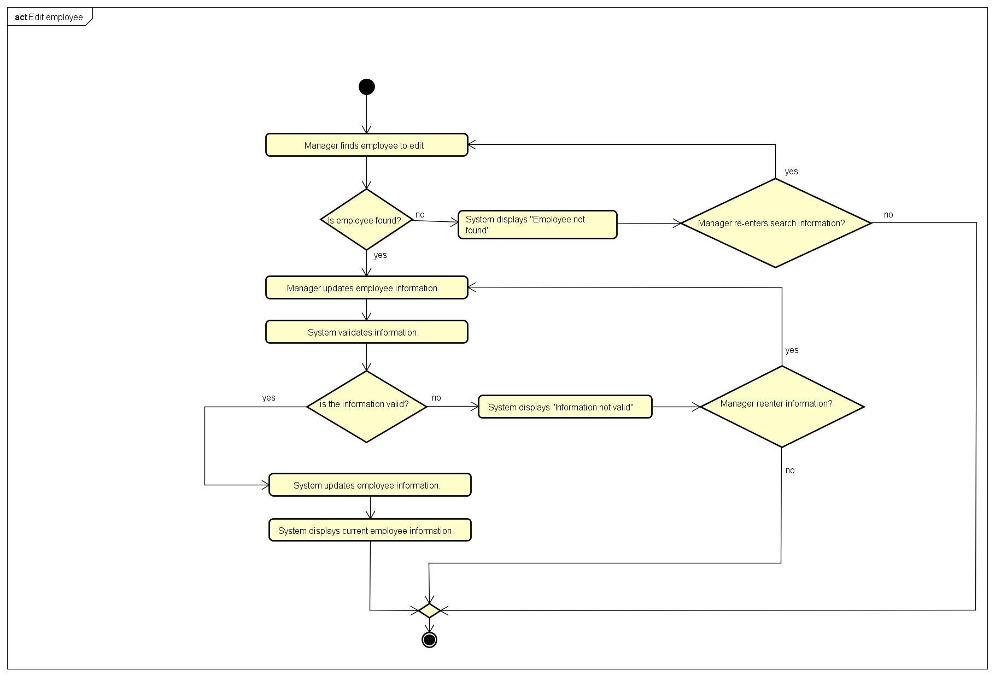

**1.10 Edit patient**

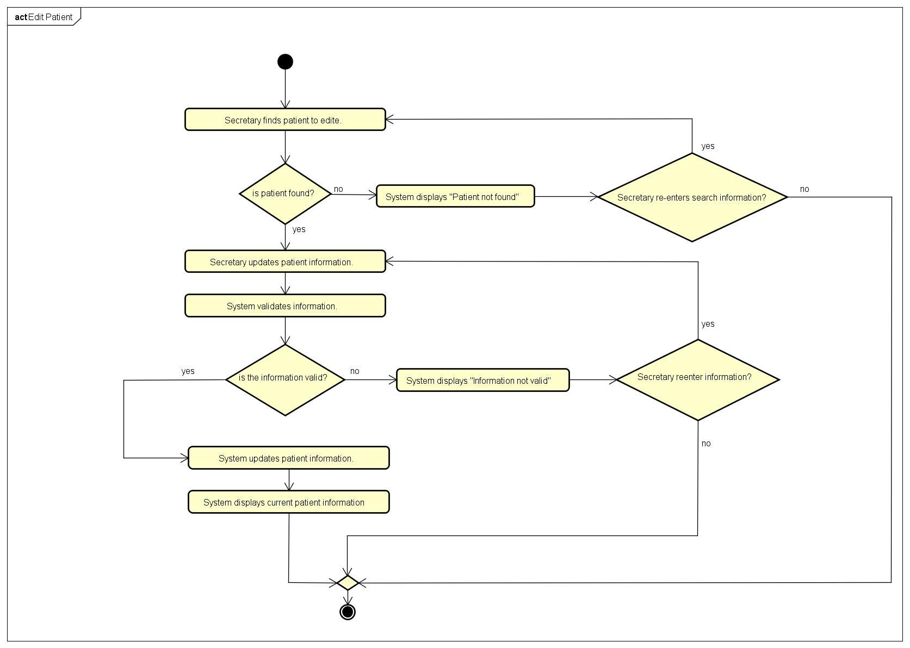

**1.11 Edit medicine**

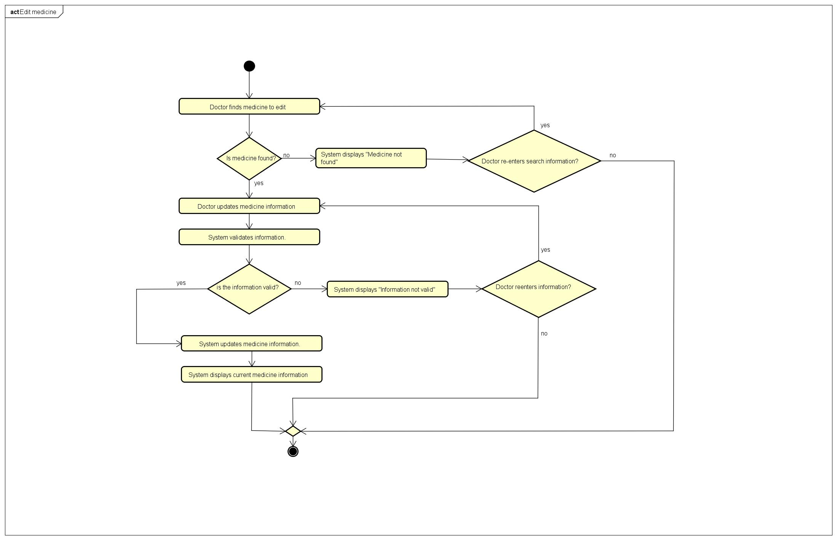

**1.12 Get lists of appointments**

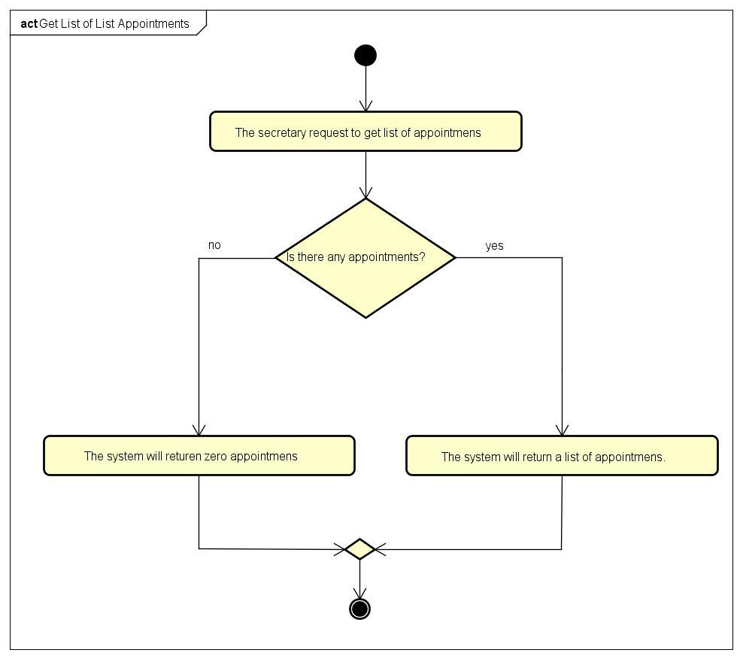

**1.13 Remove appointment**

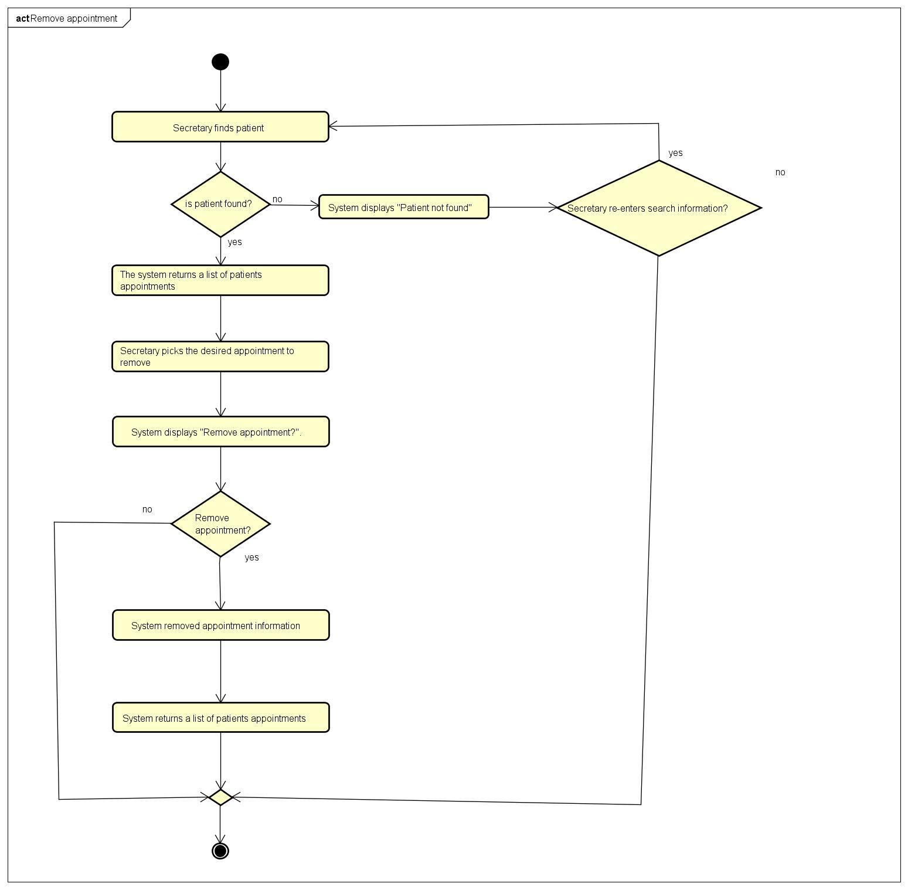

**1.14 Remove employee**

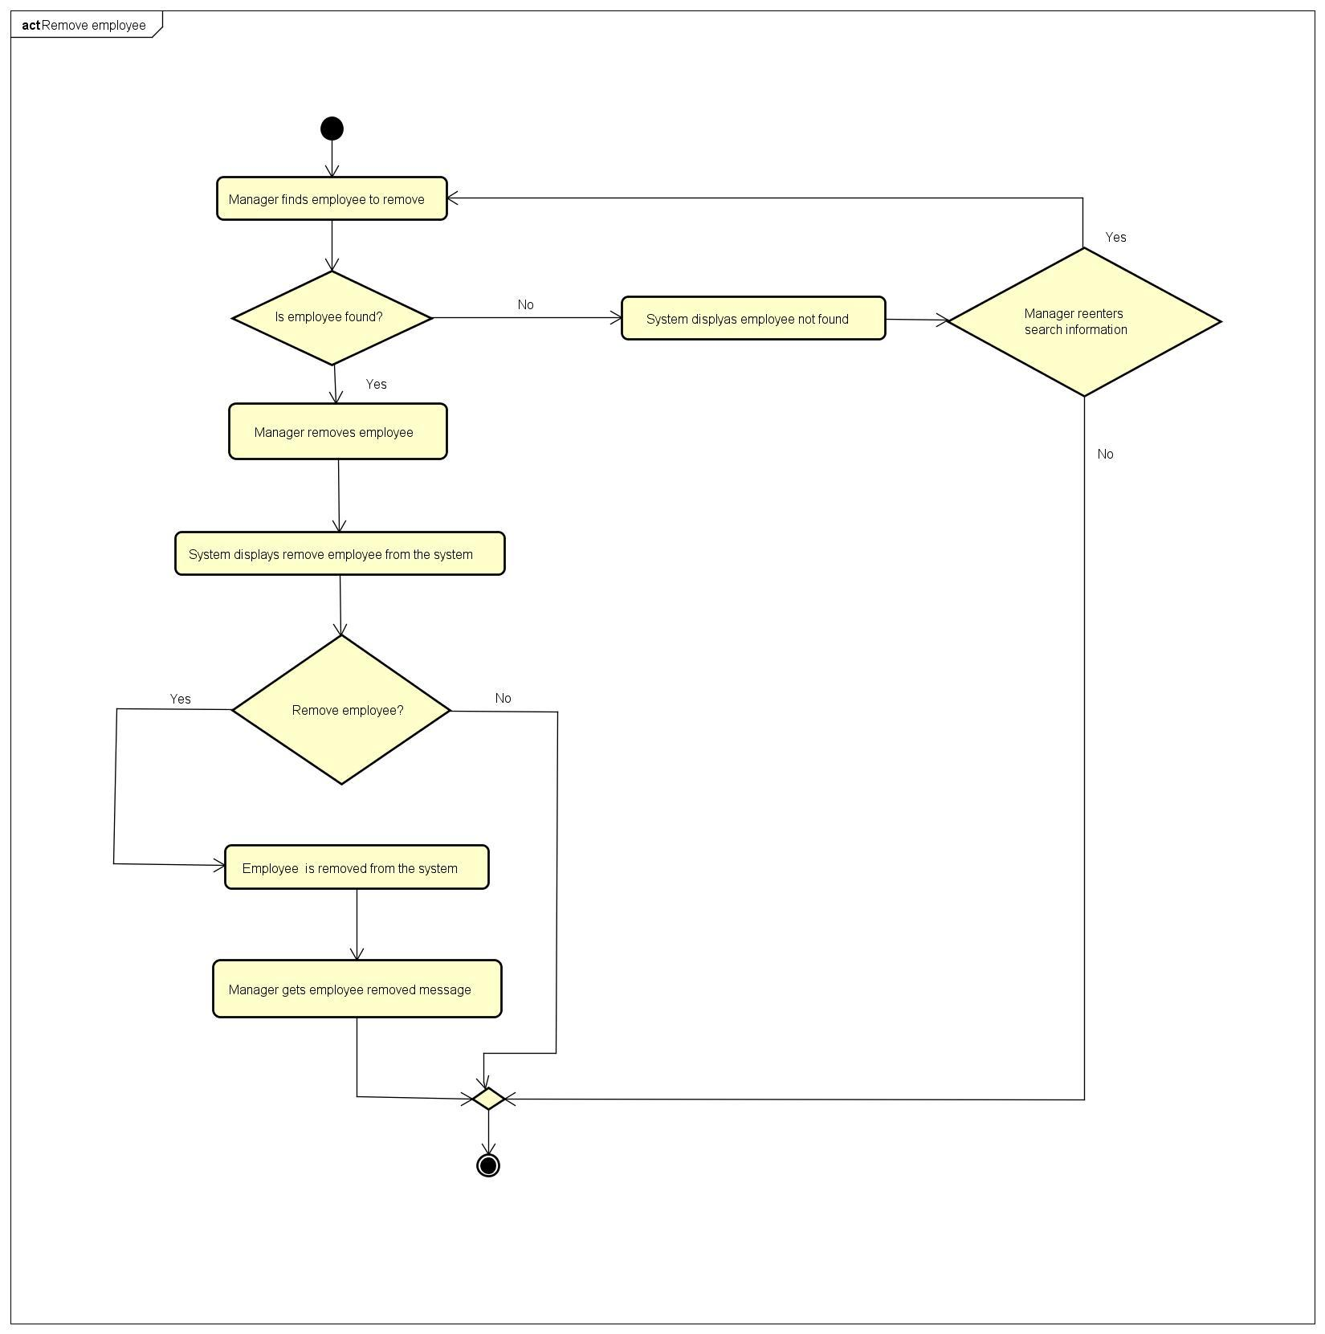

**1.15 Remove patient**

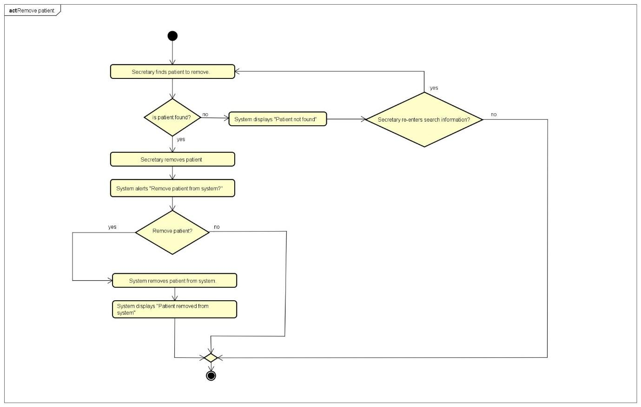

**1.16 Remove medicine**

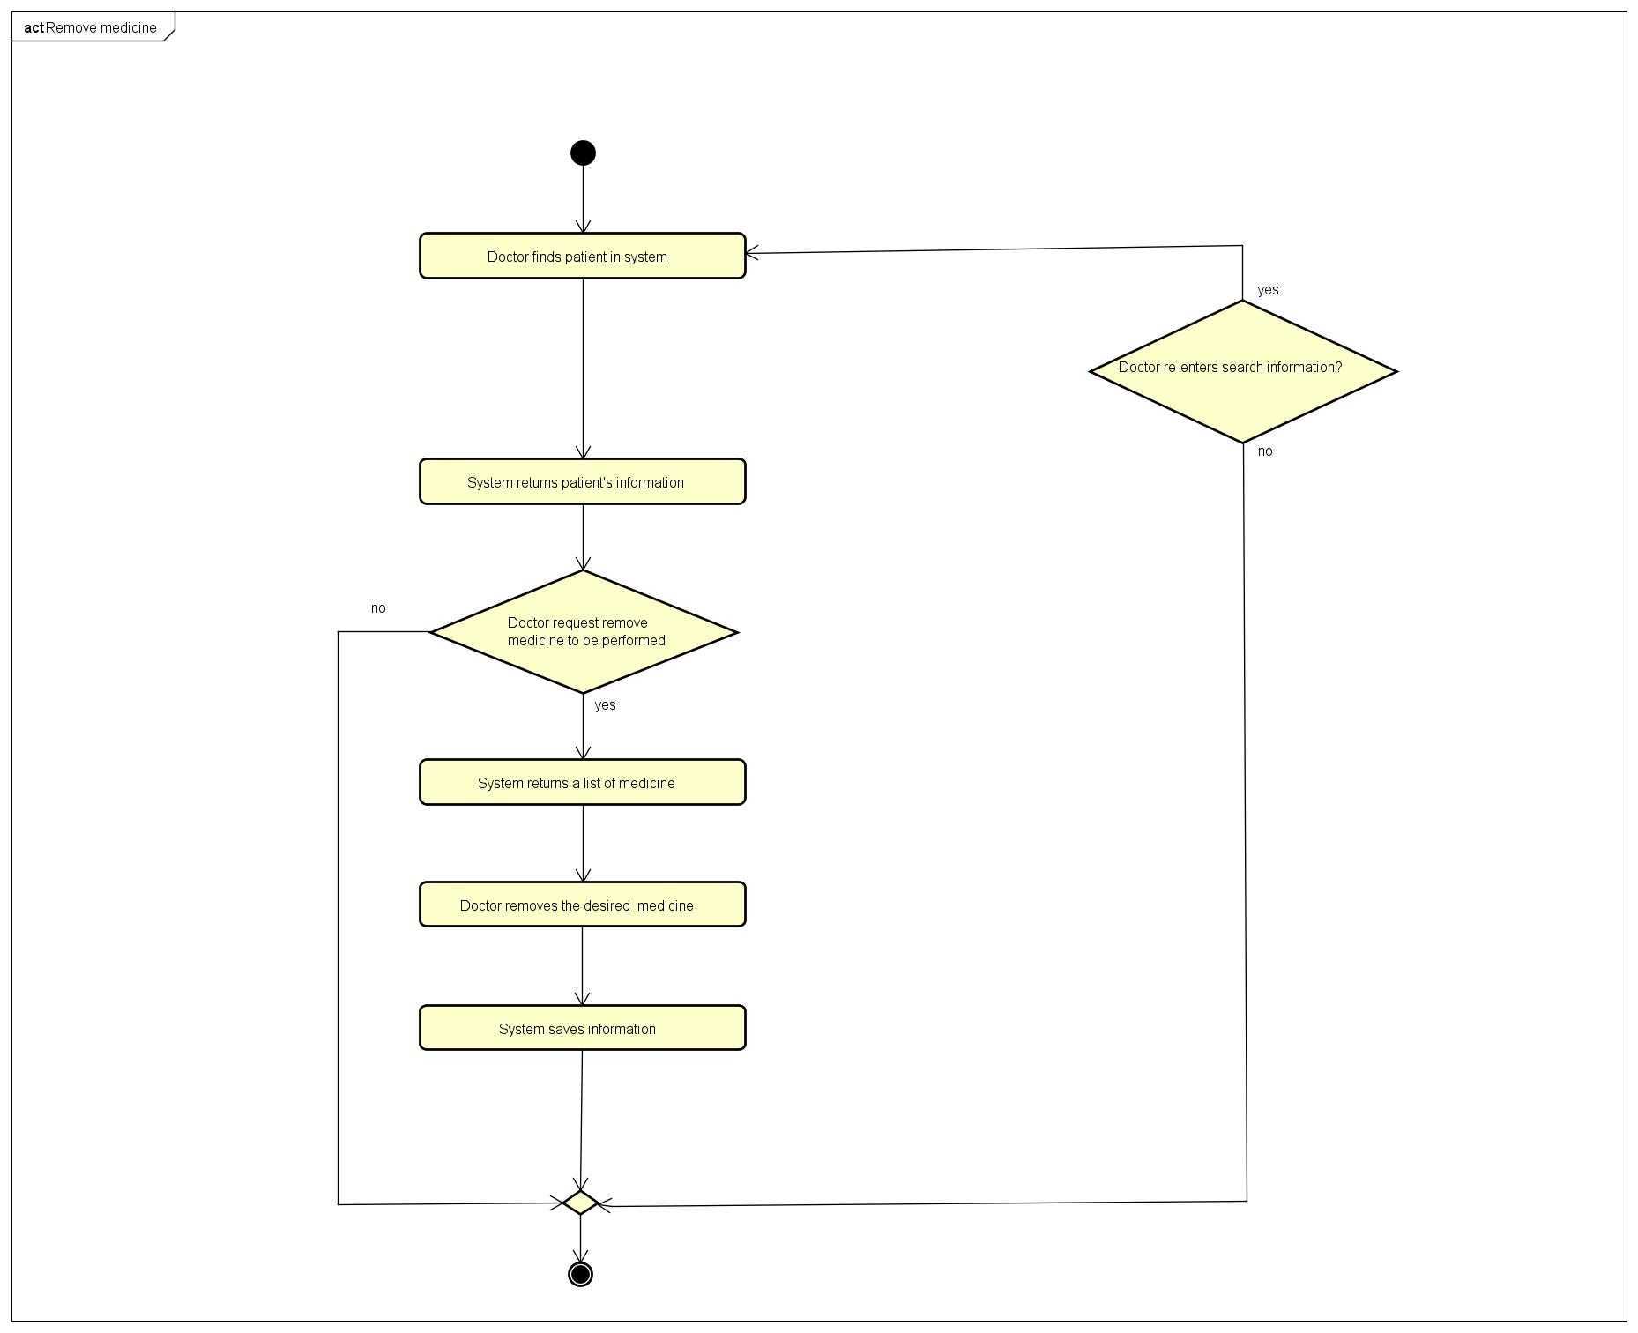

**1.17 Renew medicine**

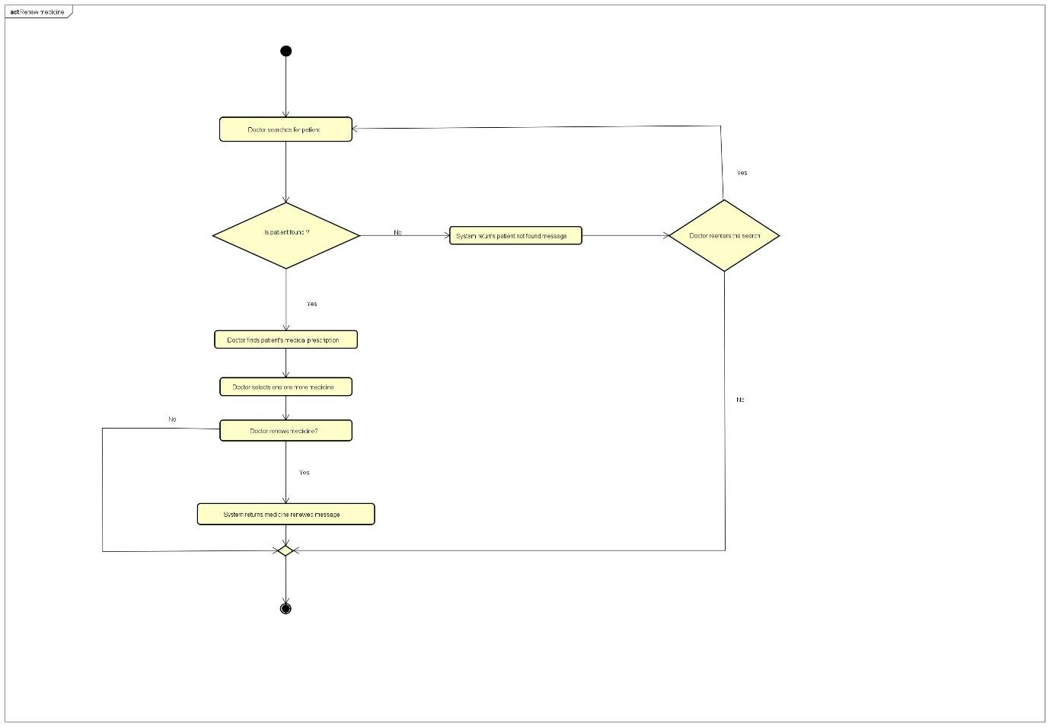

**1.18 Request medicine renew**

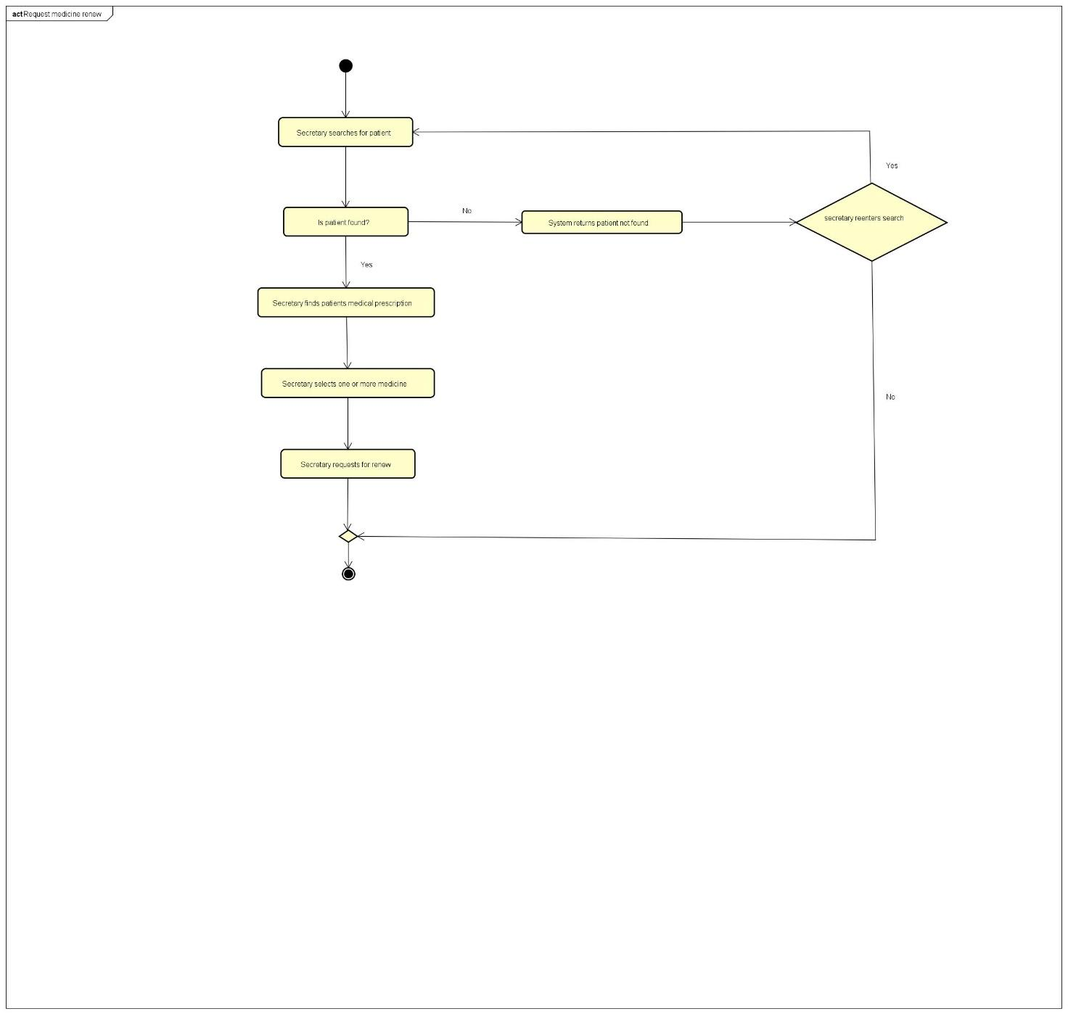

**1.19 Search employee**

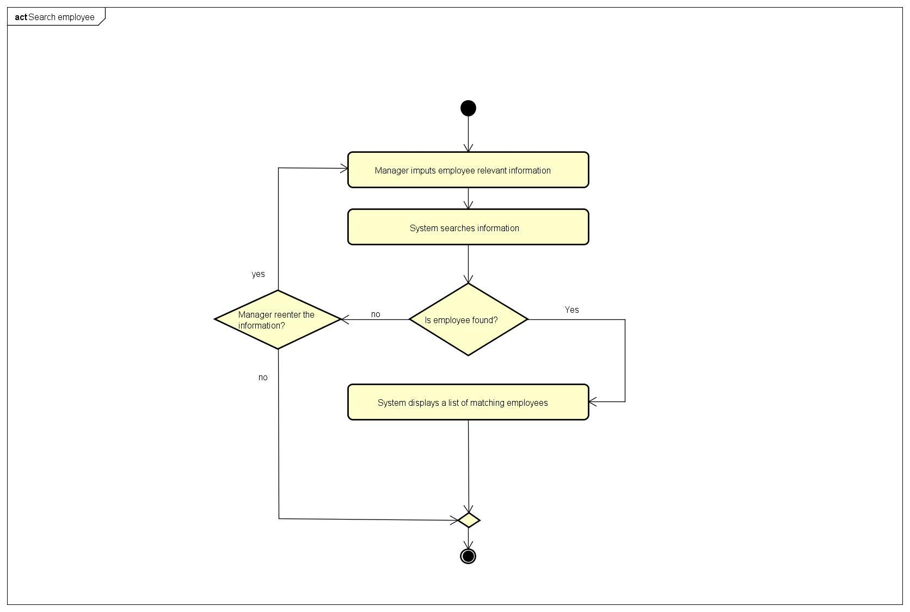

**1.20 Search patient**

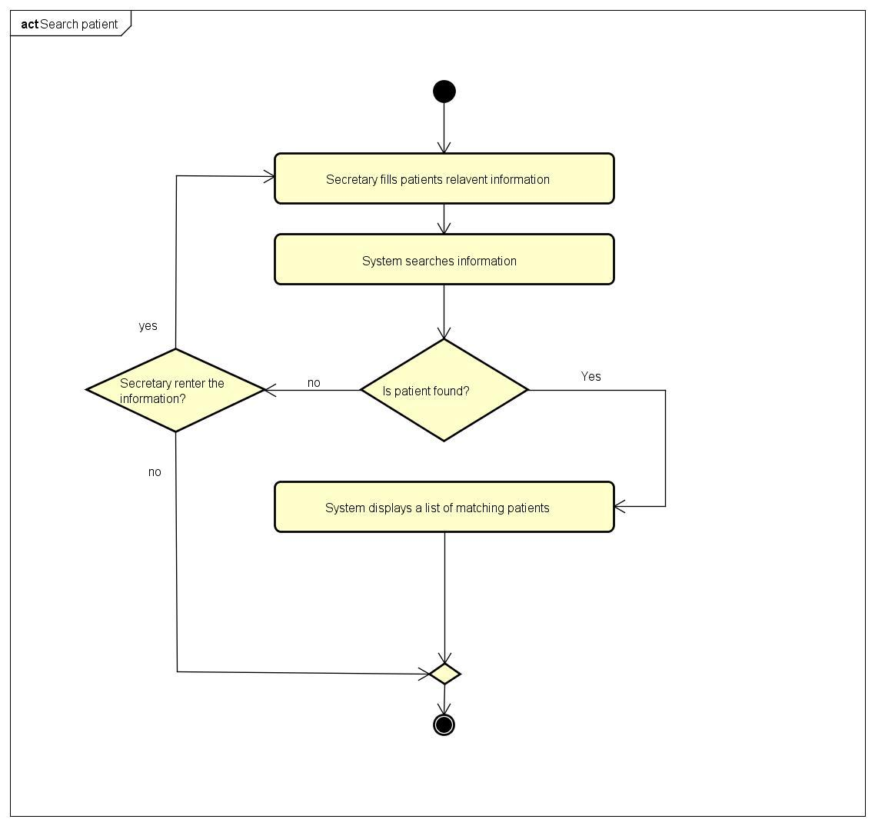

**1.21 Search medicine**

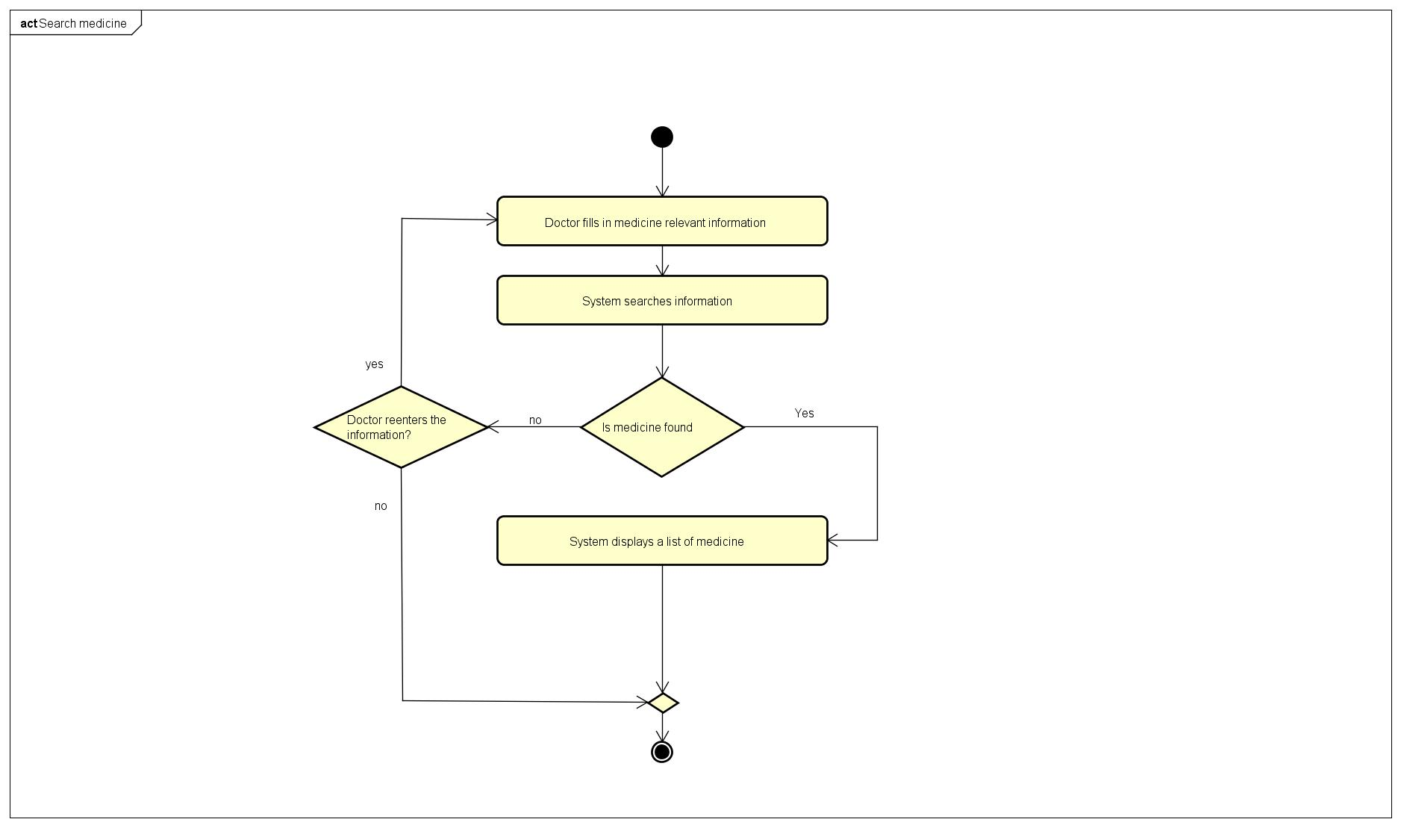

**2 Sequence diagrams**

**2.1 Add employee**

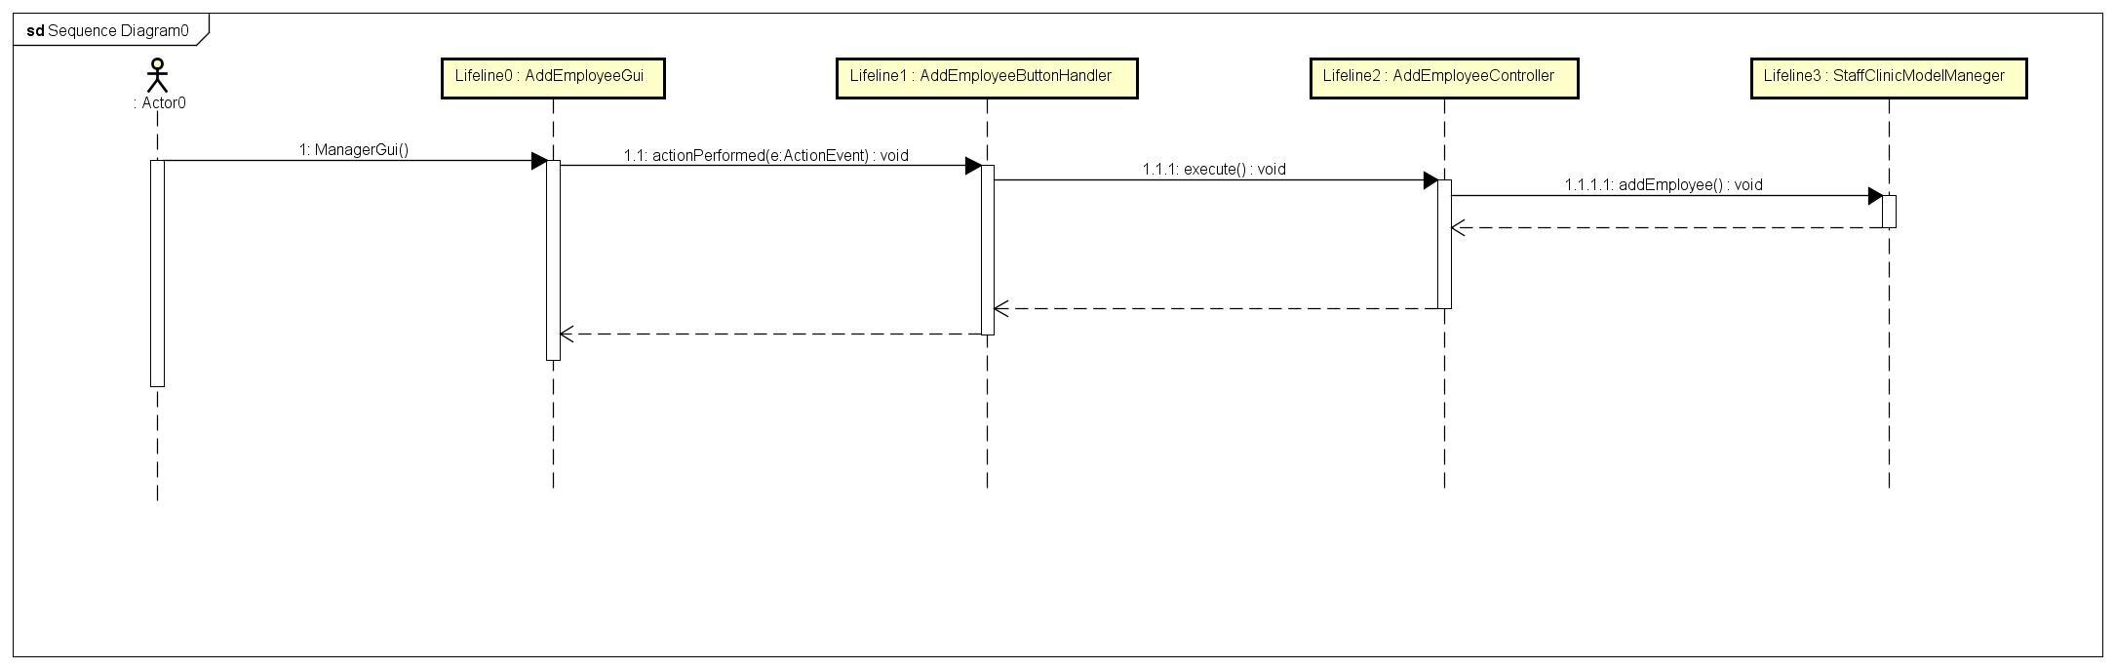

**2.2 Remove employee**

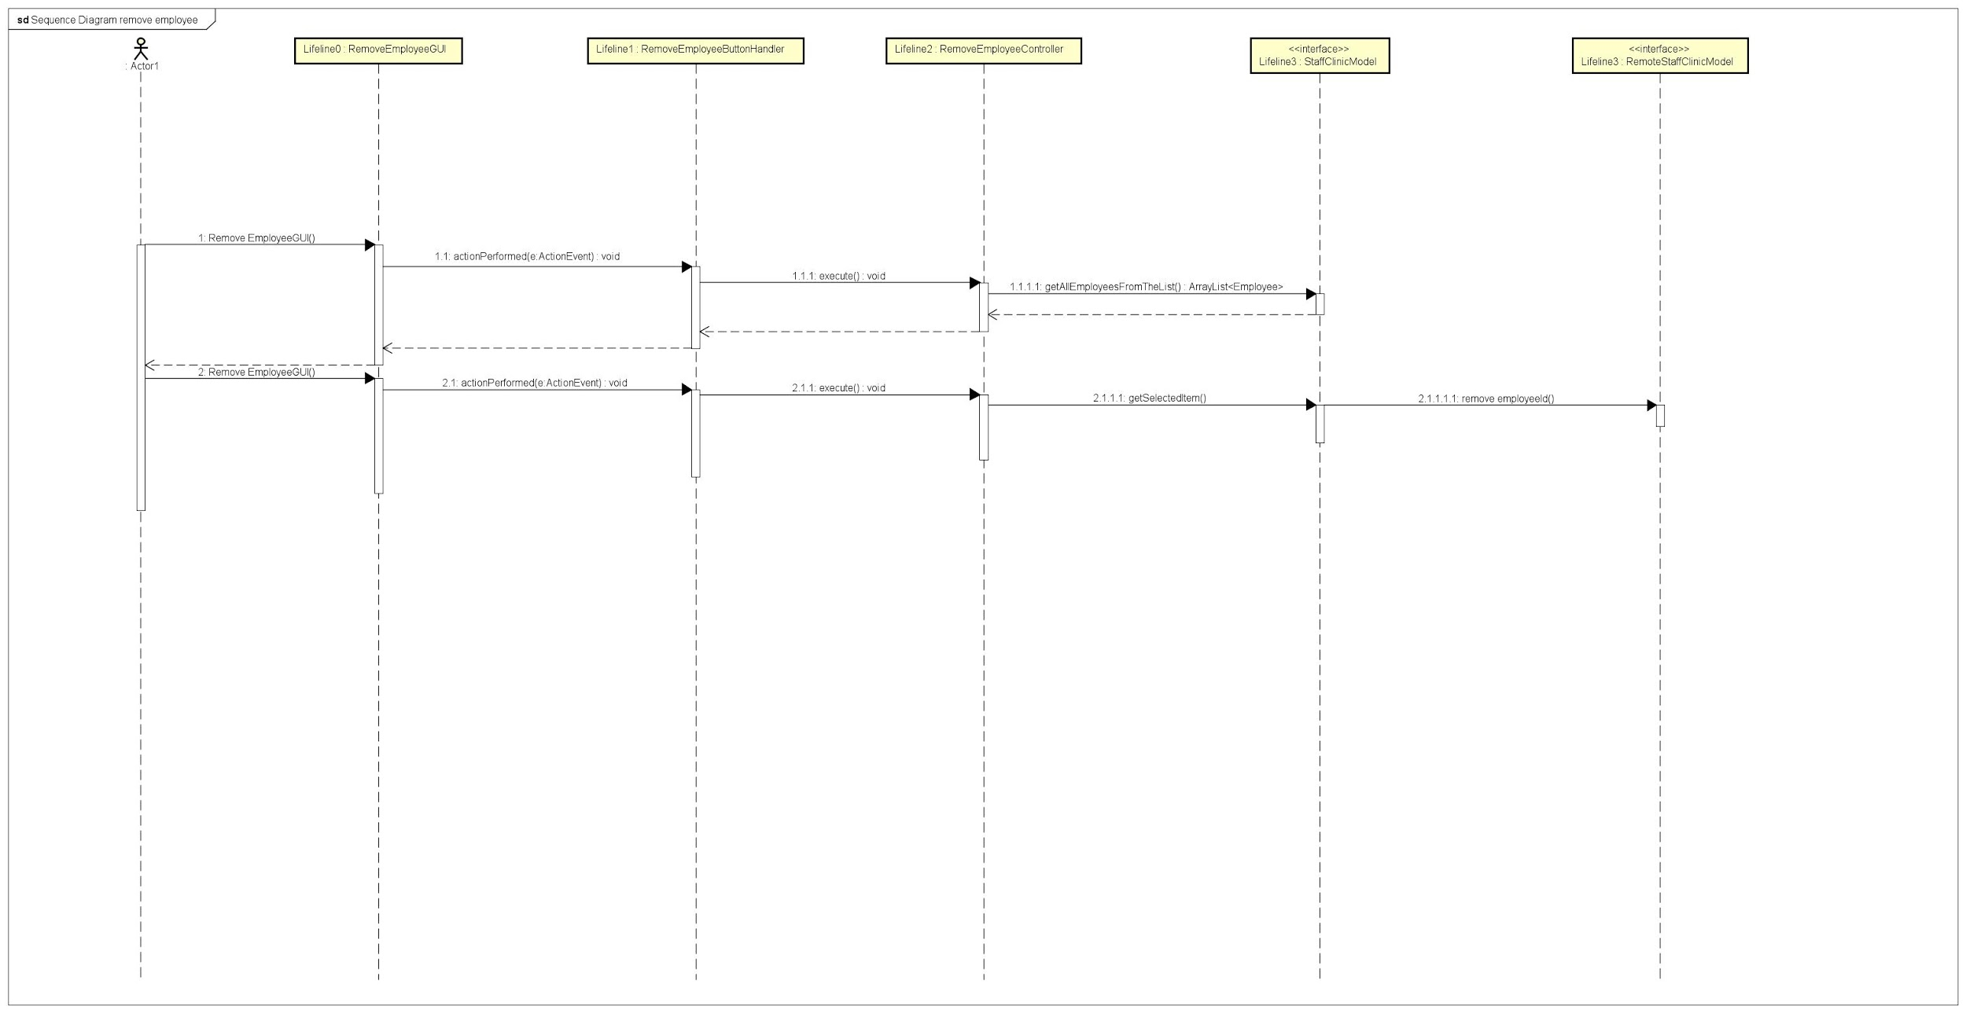

* 1. **Search employee**

